ANNUAL DEGREE PROGRAM ASSESSMENT REPORT

Overview
The emphasis of the report should be on PLO and CASLO assessment, action items emerging from those assessments, and a table listing the top three budget requests from each degree program. Bullet points are certainly acceptable for the sections requiring written responses. Refer to the ARPD Instructions when you upload your report elements to the system website. The roman numerals indicate the corresponding system item number for when you upload your report to the UH System website.
http://www.hawaii.edu/offices/cc/arpd/instructional.php?year=2015&action=quantitativeindicators&college=HAW
Select Maui College and your program in the drop down menus.
On the page that shows the Quantitative indicators, click on “web submission”. You will log in to get to your program submission pages.

Remember to click on “save” icon for EACH SECTION.

See the end of this document for more assistance with web submission.

2015-16 Program Review preparation guidelines
Program Name: Business Careers
ANALYSIS TAB
I. Quantitative Indicators
Discussion Not Required.
II. Analysis of the Program
- Any new significant program actions (new certificates, stopout, gain or loss of positions) as results of last year’s action plan. Full-time faculty member retired at the end of 2015, and we were able to hire a full-time instructor to maintain 2 full-time instructors in the area. We began reviewing the curriculum and PLOs and are in the process of vetting these, with a projected launch in fall 2017.

- If relevant, share a brief analysis for any Perkins Core Indicator not met. n/a

III. Action Plan
- Action Plan

  - PLO to be addressed: 2. Analyze and explain basic business transactions and financial reports.

  - Program improvement: The proposed new curriculum will feature 2 higher level Accounting classes, as well as the addition of 2 classes in Economics so students will better understand the financial aspects of business.
IV. Resource Implications:
The campus budget process aligns with the State of Hawaii biennium budget timeline. The next UHMC budget process will be initiated at the beginning of fall semester 2017 for the next biennium. Mid-biennium requests should address a critical need submitted through your department chair.
DESCRIPTION TAB
Provide a brief description of your program and program mission:
The Business Careers program provides quality credit instruction to students and business professionals who wish an affordable education in a supportive environment. The program provides the first two years of a business education that can be used to enhance career possibilities and used as a springboard for additional education

P-SLOs TAB
- PLO selected for assessment (click on the PLO assessed – it will turn green).

  - Industry Validation (check all that apply):

Advisory Committee Meeting(s) _X_, How many? _4_
Did Advisory Committee discuss CASLO/PLO? Yes_X_ No__
Coop Ed Placements _no_ Fund raising activities/events _no_ Service Learning _no_
Provide program services that support campus and/or community
Outreach to public schools __
Partner with other colleges, states and/or countries _X_
Partner with businesses and organizations __
Other__ Describe_______________________________________________________________

  - Expected level of Achievement:
For the PLO assessed, _65_ % of students completing the assignment/course expected to meet expectations for the assignment/course.
  - Courses (or assignments) Assessed: MGT 122

  - Assessment strategy/Instrument/Evidence (check all that apply):
Work Sample__ Portfolio__ Project __ Exam _X_ Writing Sample __
Other__ Please explain_________________________________________________

  - Results of program assessment:
    - The following were present at the PLO assessment: Business Careers, BUSC Advisory Board, Eric Engh
    - Strengths and weaknesses (best practices and educational gaps) found from PLO assessment analysis. We found that the instrument (a final exam) did not allow for accurate assessment of the PLO, although it did allow for good assessment of the class itself.

  - Other comments:
Describe CASLO assessment findings and resulting action plans. Go to Laulima UHMC CASLO Assessment for your program’s “Assessment results” and summarize below.

CASLO assessment findings | Action plan to address findings
The “minimally passing” evidence did not seem to support a skill level of Critical Thinking at a level appropriate for the degree. | The class will feature a final project that will better incorporate this.
The assignment was more recall than critical thinking. | The class will feature a final project that will better incorporate this.

  - Next steps:
For program learning outcomes (check all that apply):
Assess the next PLO__X_ Review PLOs_X__ Adjust assignment used for PLO_X__
Adjust course used for PLO___ Meet with Advisory Committee__X__
Other___ Please explain:

System website:
http://www.hawaii.edu/offices/cc/arpd/instructional.php?year=2015&action=quantitativeindicators&college=HAW
Select Maui College and your program in the drop down menus.
On the page that shows the Quantitative indicators, click on “web submission”.
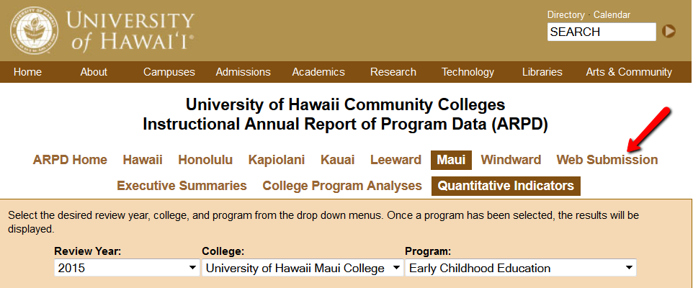

You’ll log in on the next page.
When the page with tabs comes up, click on Analysis tab.
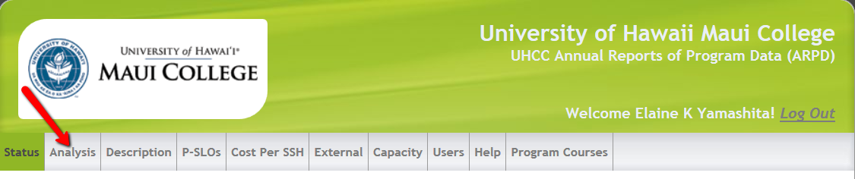

Click on “edit”. Copy and paste from this document into each section. If you are pasting from Word, you need to click on the “W” icon and then paste into the box that pops up (like in Laulima). See green arrow below.
REMEMBER TO “SAVE” EACH SECTION! (red arrow in pic below).

You’ll be entering information into:
- Analysis
- Description
- P-SLOs
- External (if your program has an external exam)

REMEMBER TO SAVE (red arrow) EACH SECTION!


